1. **Introduction**

This report aims to communicate the current status of the design, fabrication, and testing of Bulldogs Racing’s (BR) new car, BR16. The report compares the projected and current status of the project and finds that *BR16 is 4–8 weeks behind its original schedule. A*

*revised project plan is put forth.*

1. **Current Status of Project**

The following milestones were completed on time according to the Project Plan (appendix 5): vehicle architecture defined, chassis design finished, chassis work order finalized, round 1 fundraising goals met, registration for Formula Hybrid complete, round 2 fundraising goals met, Project Plan finalized, round 3 fundraising goals met (appendix 1). The following milestones were completed late: chassis delivered (appendix 2). The following milestones are overdue: high voltage, suspension, steering systems installed (appendix 3). The following milestones are in danger of becoming overdue: remaining systems installed, vehicle moves under own power, and vehicle passes testing.

An analysis of the Gantt chart found in the Project Plan indicates that in addition to the above overdue milestones, installation of the following systems should be complete: Transmission, Brakes, Impact Attenuator, Firewall (appendix 4). According to the individuals responsible for these systems, the systems are still in stages of fabrication and will require a range of 1 to 6 weeks to fabricate and install. Fortunately, the delay of these systems does not directly impact the progress of other systems.

With this information in mind, BR met as group to reorient and discuss the possibility of creating a vehicle that could compete in a mock competition (i.e. pass tech inspection and compete in dynamic events) on the 25th of March. BR members committed to this goal and

created a Revised Project Plan (appendix 6) with strategies to achieve this goal.

1. **Brief Overview of Changes to Project Plan**

The project plan was revised as major setbacks were encountered. A summary of the challenges and revisions follows:

* Cyber-attacks to the BR website halted the electric and media/finance teams. The Teams were given an additional week to accomplish goals.
* Most design teams stumble through research. Design of CAD models is delayed. Teams are given additional time to work on designs.
* Due to complexity of designs, Chassis is delivered more than a month behind schedule. Since most design teams are also behind, this has little to no effect on their progress.

To speed up production of the vehicle, BR leaders send weekly motivational emails and emphasize individual project management. As a result, the Team has increased the total

work hours of the week and committed to weekly progress reviews.

1. **Expected Results**

BR aims to produce a reliable vehicle and stresses this over other aspects of the project. Engineers on the team now emphasize ease of fabrication and assembly over weight and creativity in design. As a result, we expect the car to weigh 3-5% more and perform accordingly. However, BR does not see this as a competitive disadvantage and expects to do well at the competition.

**Appendix**

**1. Sponsors**

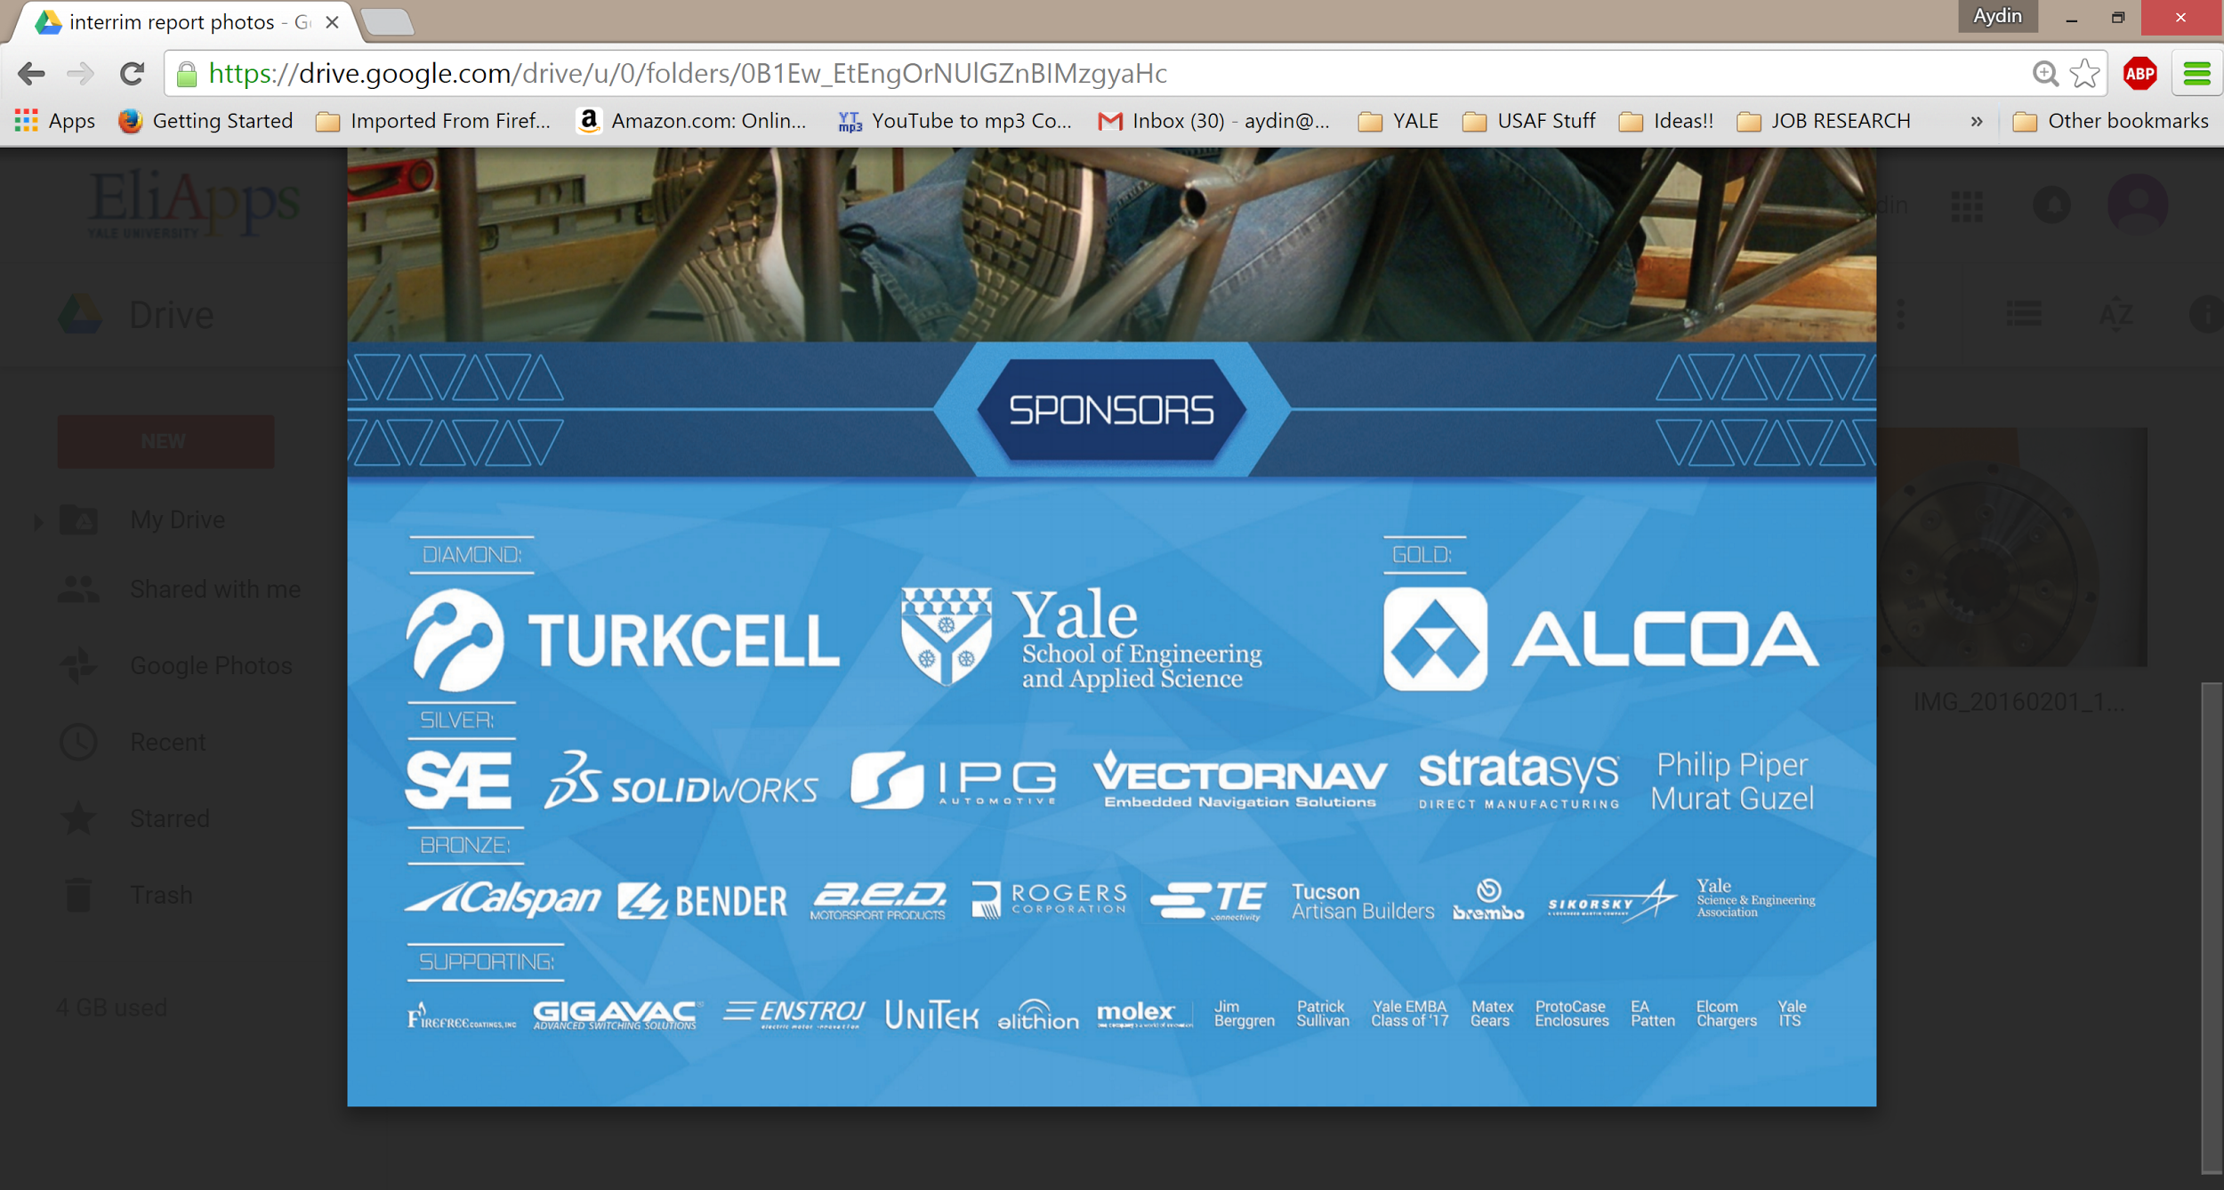

**2. Chassis Arrival**

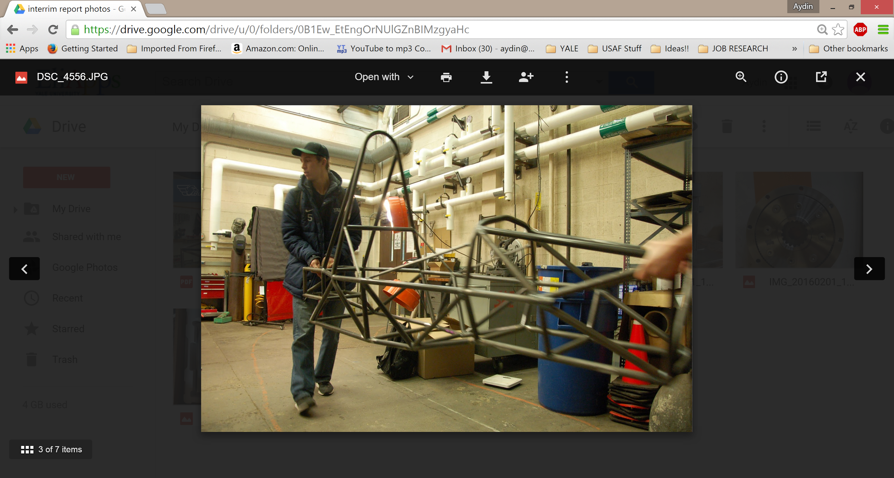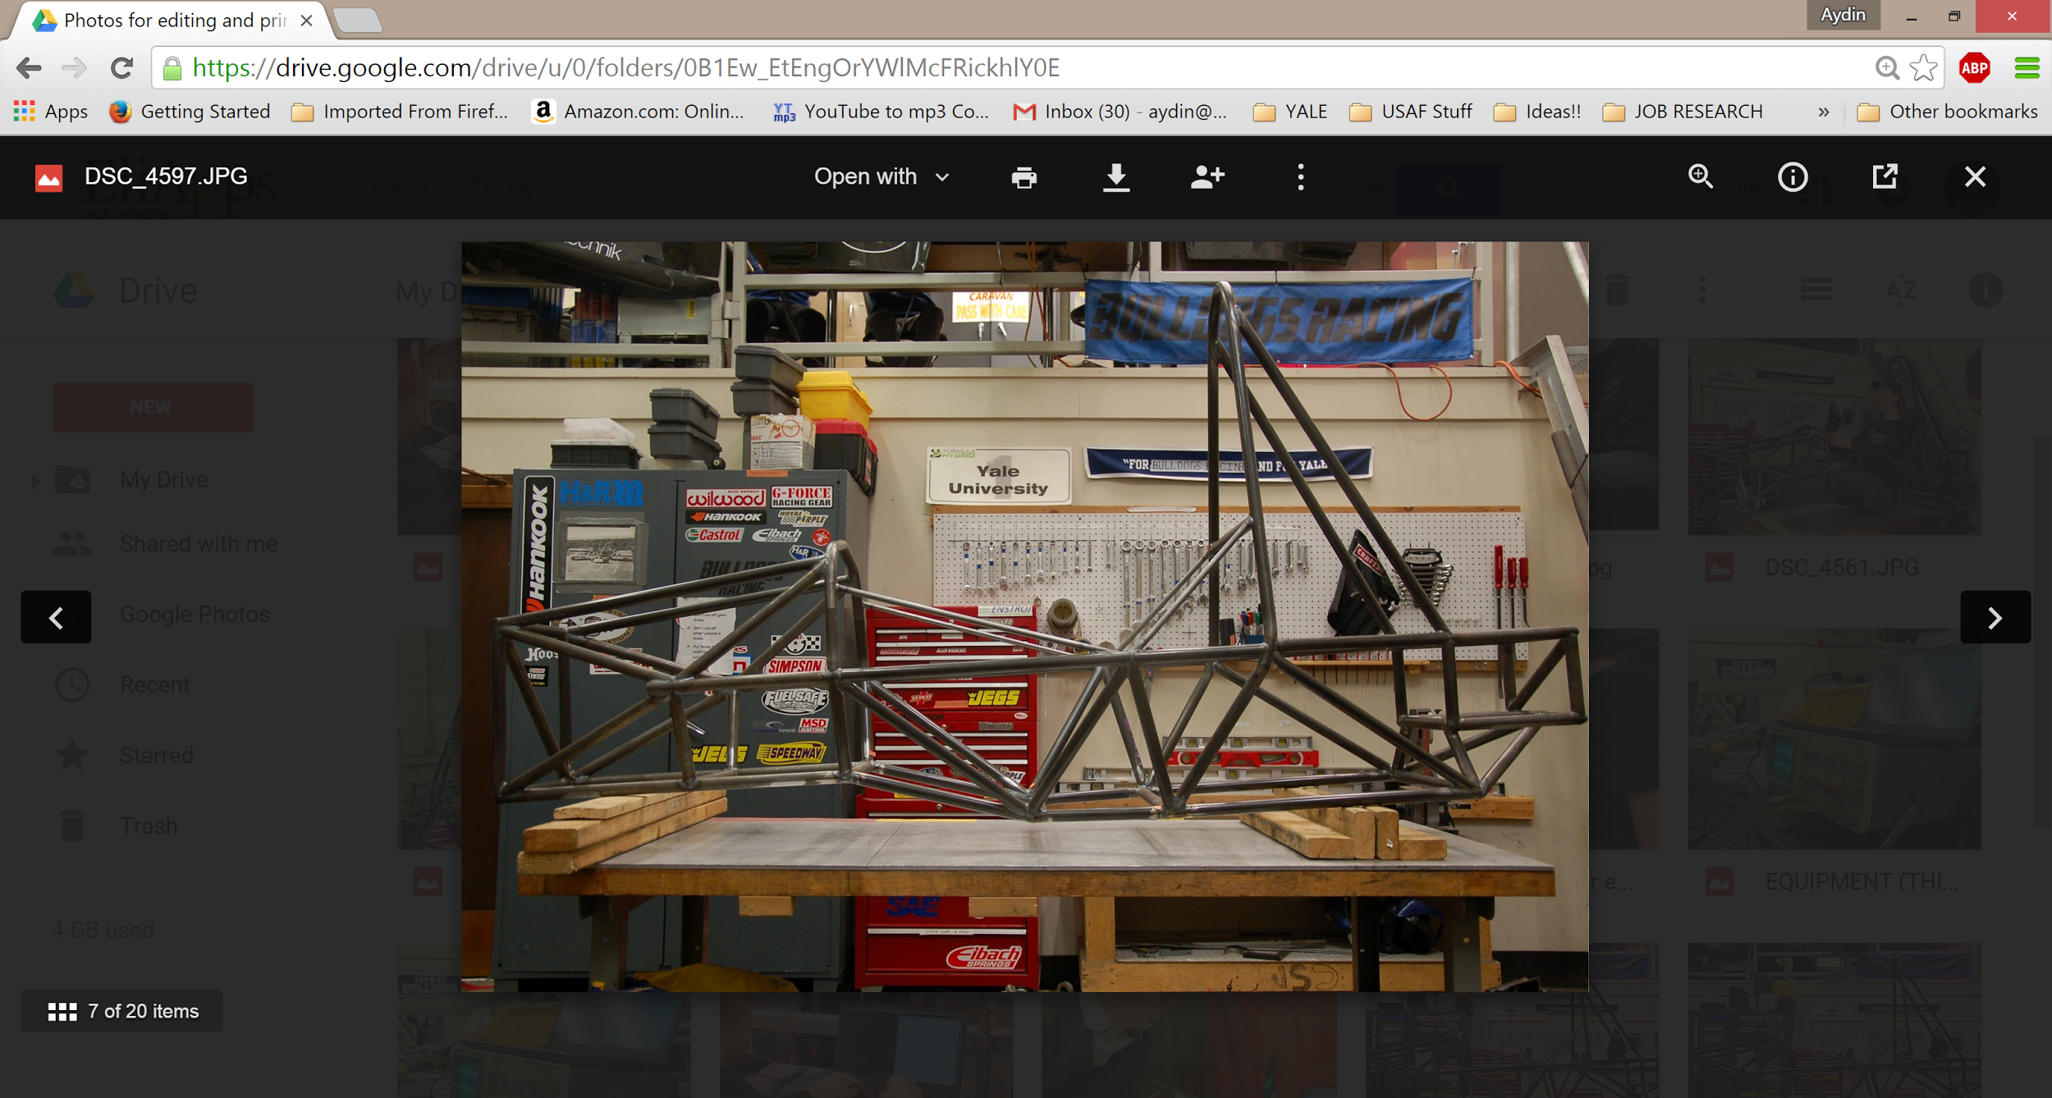

**3. High Voltage Components**

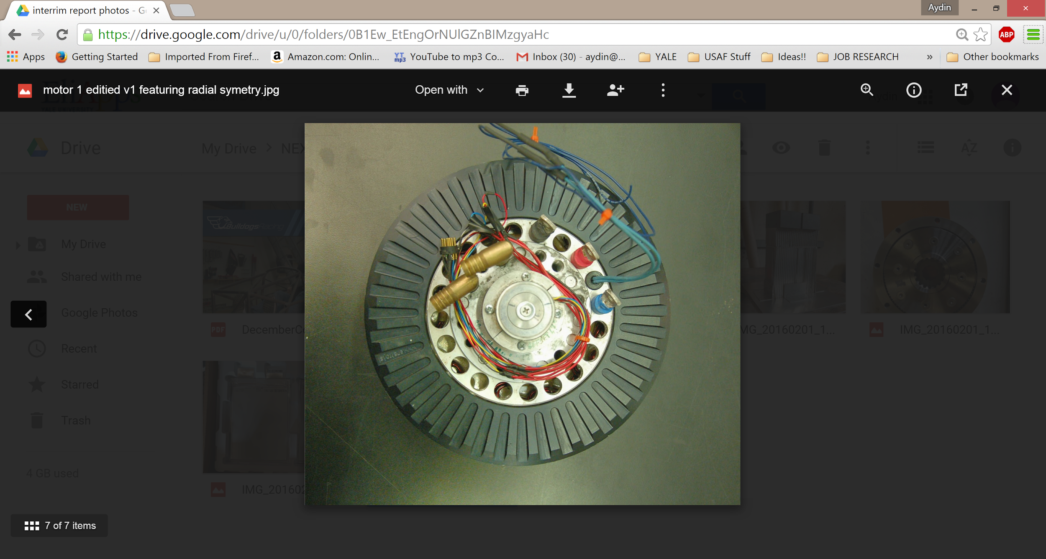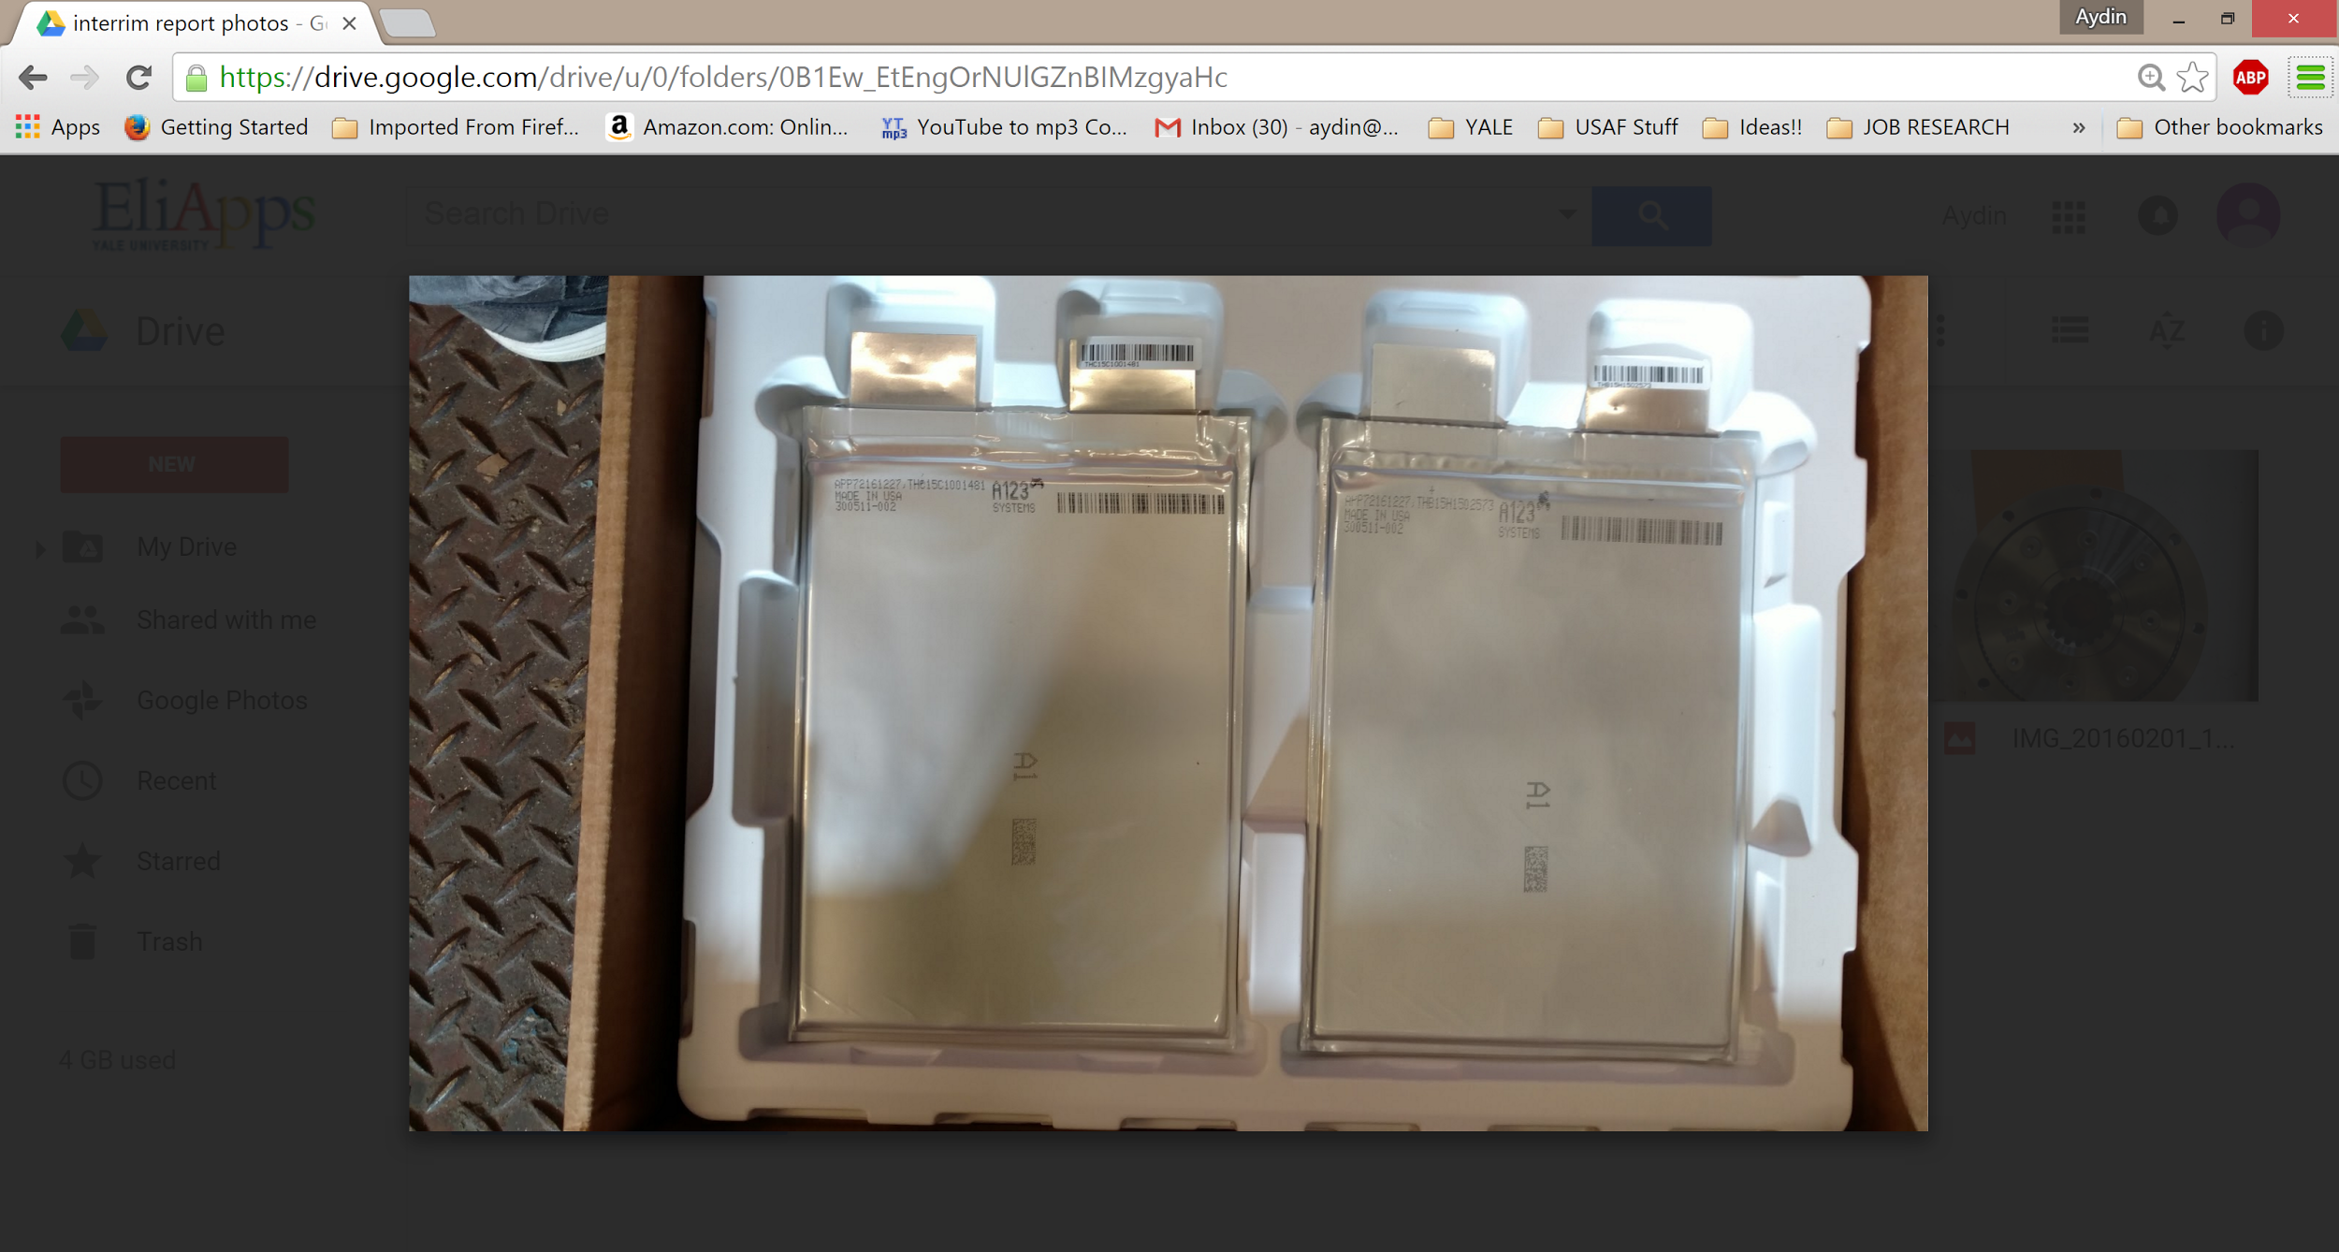

**4. Transmission, Impact Attenuator**

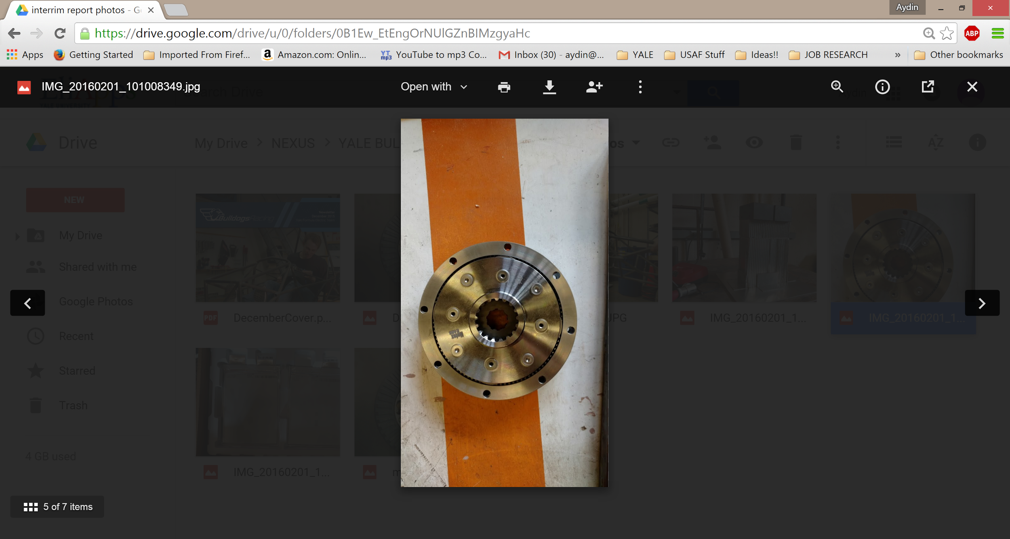 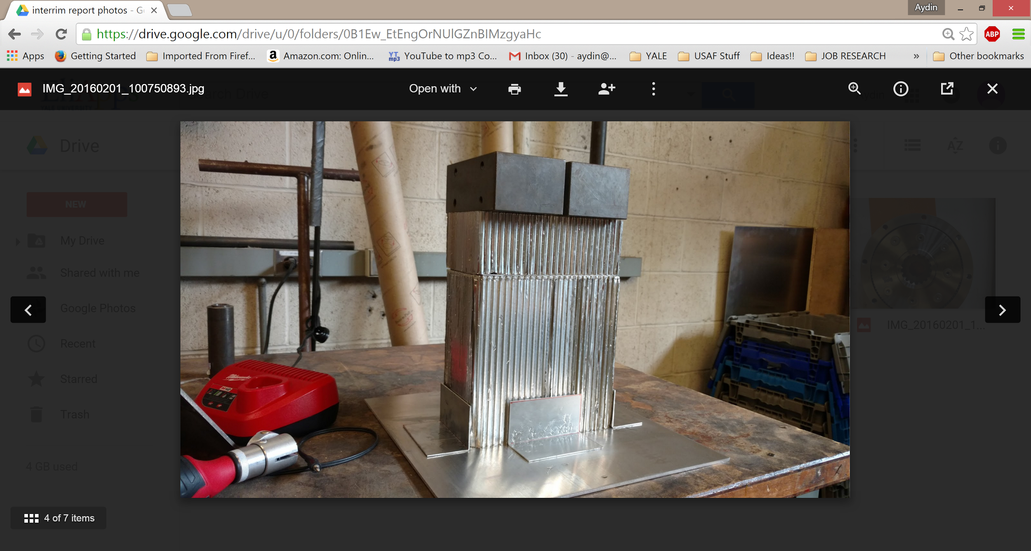

**5. Original Project Plan**

(See following page)

**6. Revised Project Plan**

(see following page)